Add in category name next to Supplier’s name under the Supplier Listing
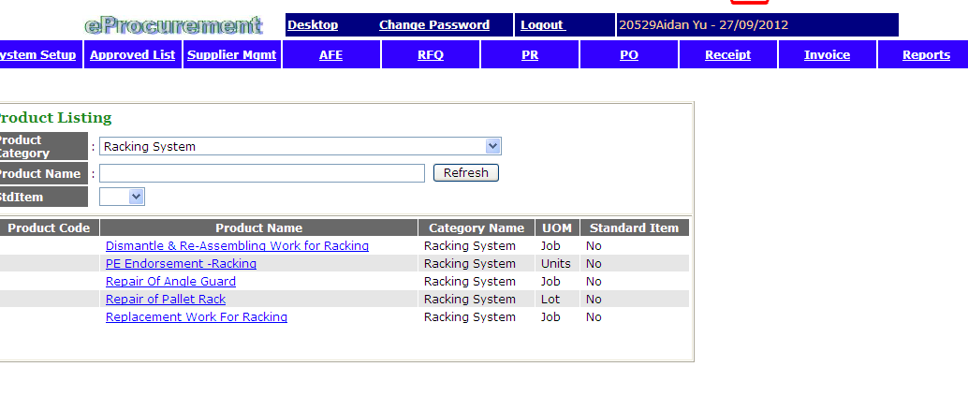

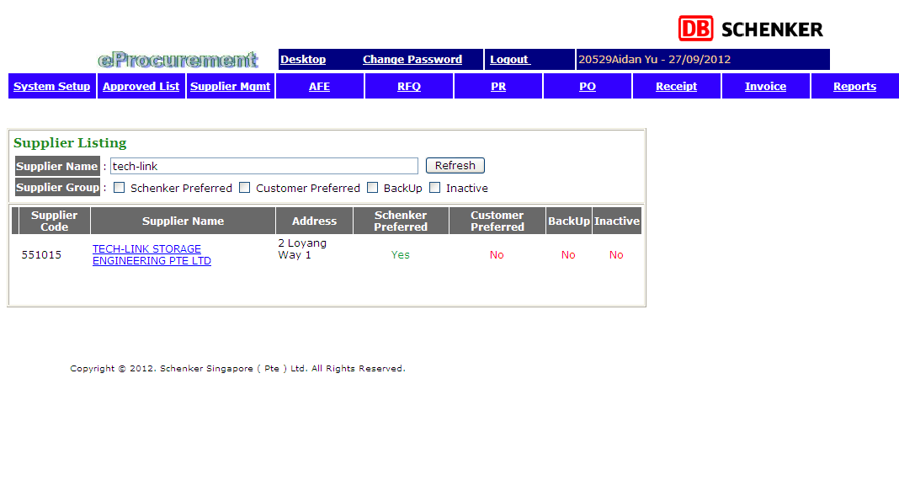

Purpose of this ASR is to enable end users to know what supplier is supplying.

End users should also be able to sort by Product Category to pull out suppliers that supply a particular category.

